Natasha Kandengwa

1519045

Portfolio Learning Task 3 Report

Sound Mixer Studio App

**Table of Contents**

* 1.A description of how your application works (supplemented by screenshots including instructions on how to run it on your chosen platform (e.g. browser, etc.).
* 2.Application Development. This section should describe your implementation. Programming code and diagrams describing algorithms should be included.
* 3 a. testSoundE.wav. Use it to test your spectrogram visualisation. What is the sound file named testSoundC.wav?
* b. Spectrogram analysis- audio search algorithms (e.g. Shazam).
* 4.An analysis of the finished application. Issues that occurred during development and how they were overcome.
* References

**Soundapp**

Soundapp is a Dj mixing web application that enables the user to select and load two music files from the user’s computer and play them one at a time and simultaneously. (fig 1) The application is made up of two canvases player 1 and player 2, both with the same functionalities that include:

* *File selection*- User selects and loads a music file from the computer
* *Play button*- user can play the selected music file
* *Pause button*- user can pause the selected playing file
* *Stop button*– user can stop the selected file from playing
* *Volume slider*- user can control the volume of the playing file by moving the slider

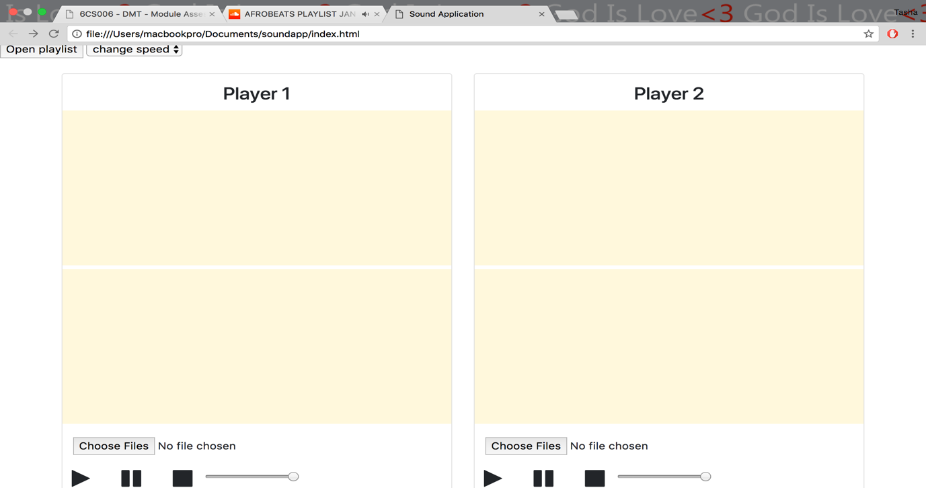

*Fig 1- Soundapp user interface*

(Fig 2)-The application enables the user to load a file and load it on to the the player 1 canvas.

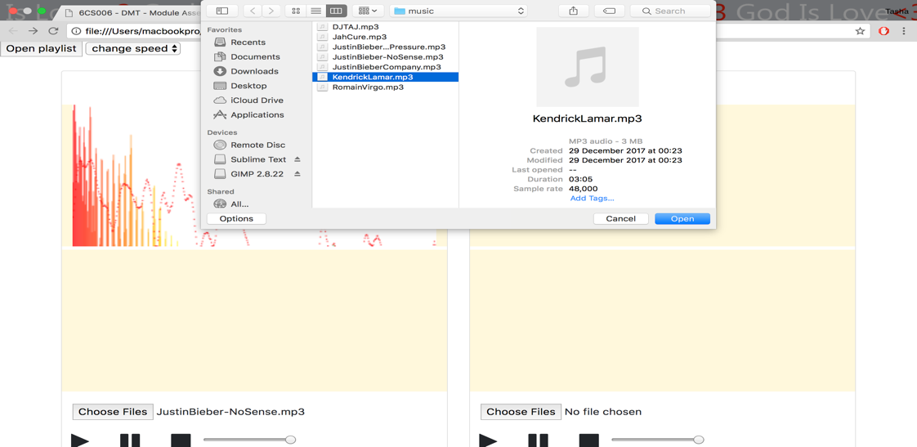(fig 3)- While the file is playing on Player1, the user can select and load a second file from Player2 canvas.

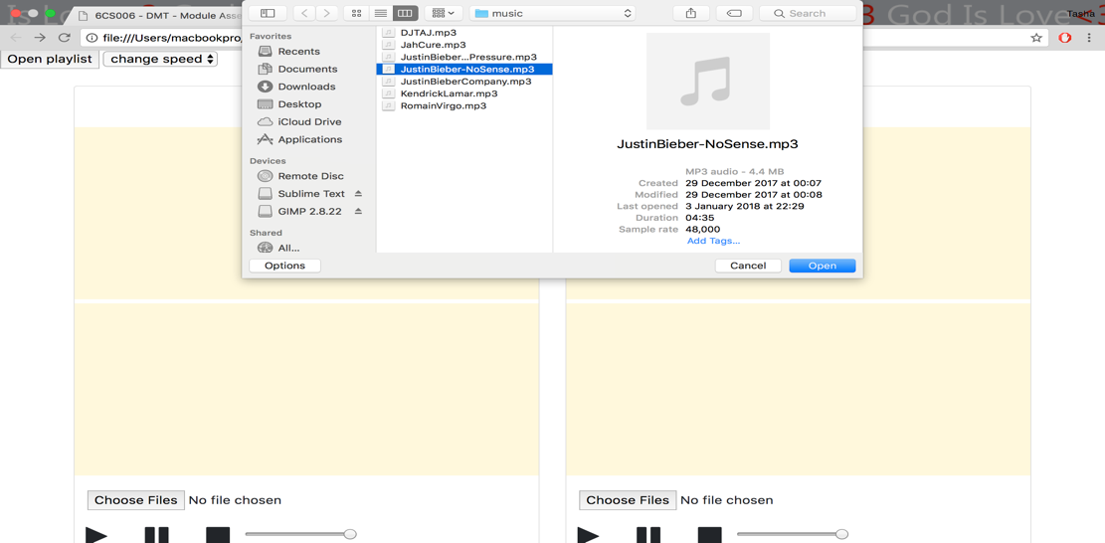*Fig 2- Player 1 file selection fig 3- Player 2 file selection*

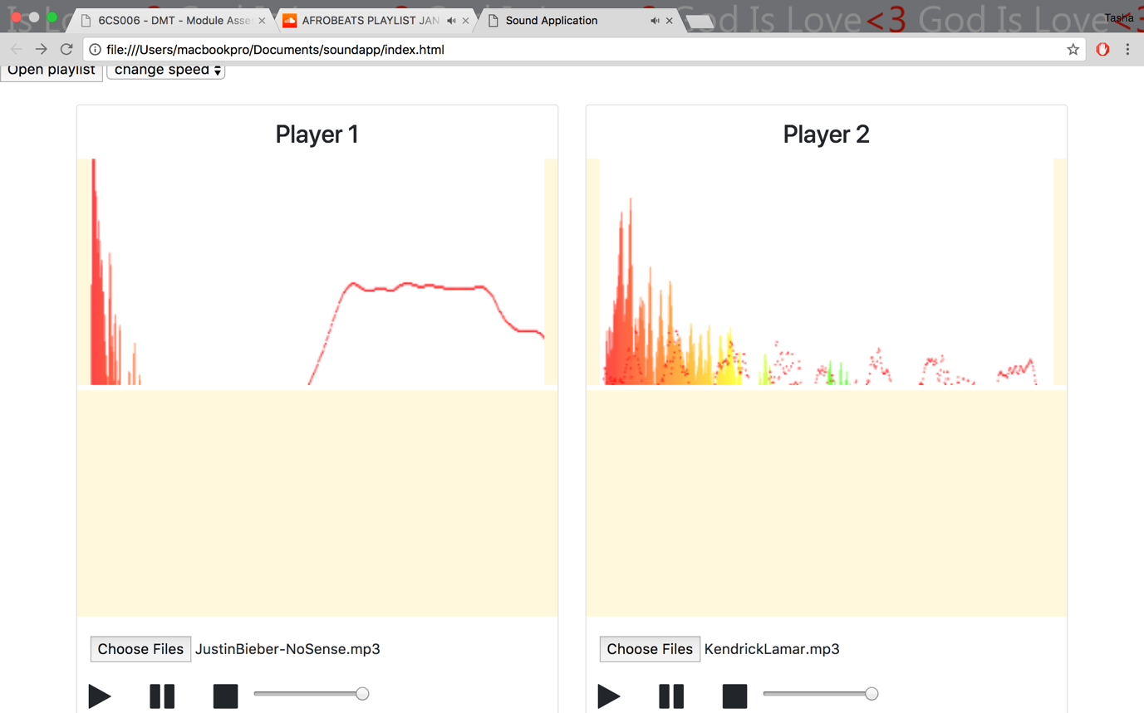

*fig 4-two files playing simultaneously*

Filter options are provided on both canvases. The selected filter will be able to be applied on a playing song and immediately change the sound of the audio. Fig 5 shows the list of filter options available on each canvas, (player1 & player2).

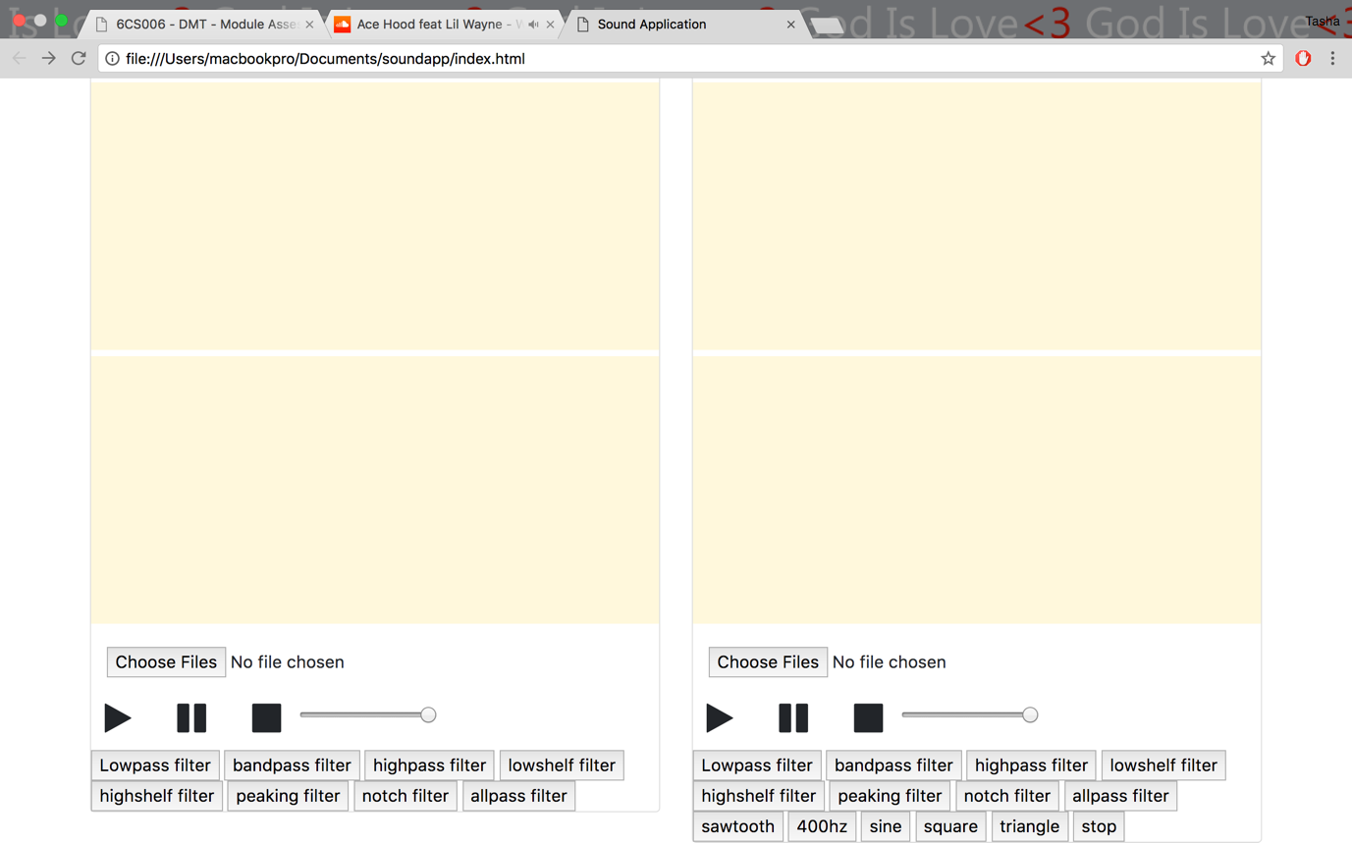

*fig 5- filter options*

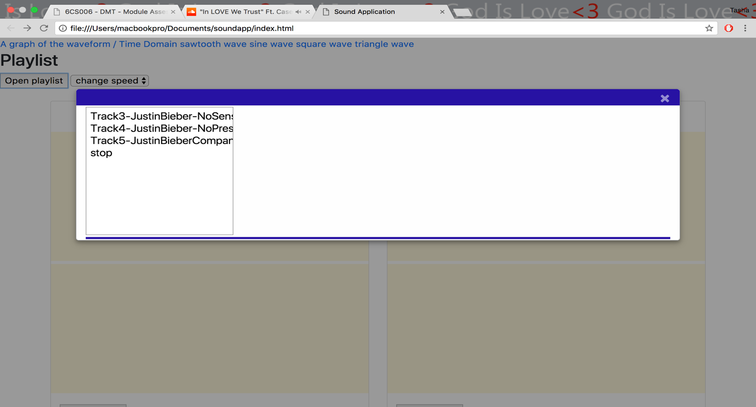

*fig 6- Playlist*

Not only can the application load music files from player1 and player2 canvases, the application also includes an option to view a particular playlist with music files. Users will be presented with a list of songs to browse, select and play. When a user clicks on a particular song, the audio file plays until the user clicks the stop button.

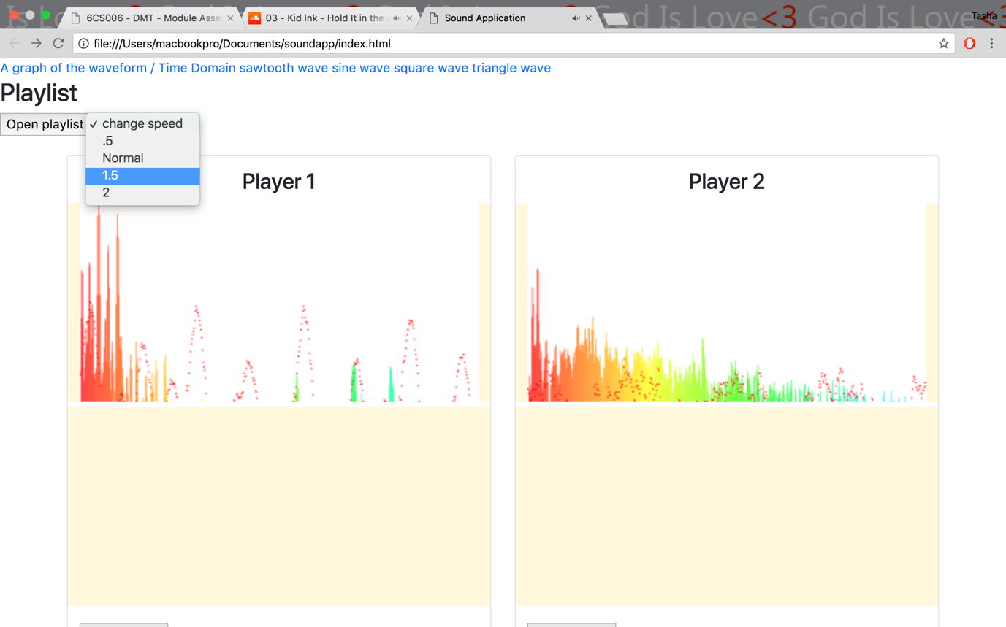

*fig 7- Sound speed control*

The sound speed control is used to manipulate the playing speed of an audio file. When a user loads and plays a song on the canvas, the change speed option provides settings to switch the playing speed of the audio file by selecting options in the speed list. When an audio file is loaded, the audio speed is normal by default, .5 is to half the playing speed, 1.5 is to increase the speed and 2 is to double the playing speed.

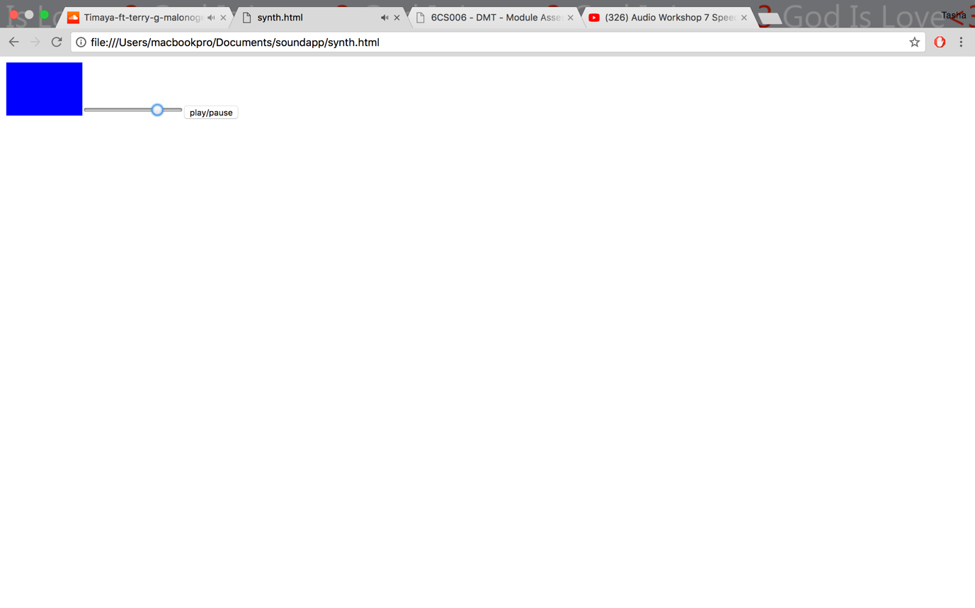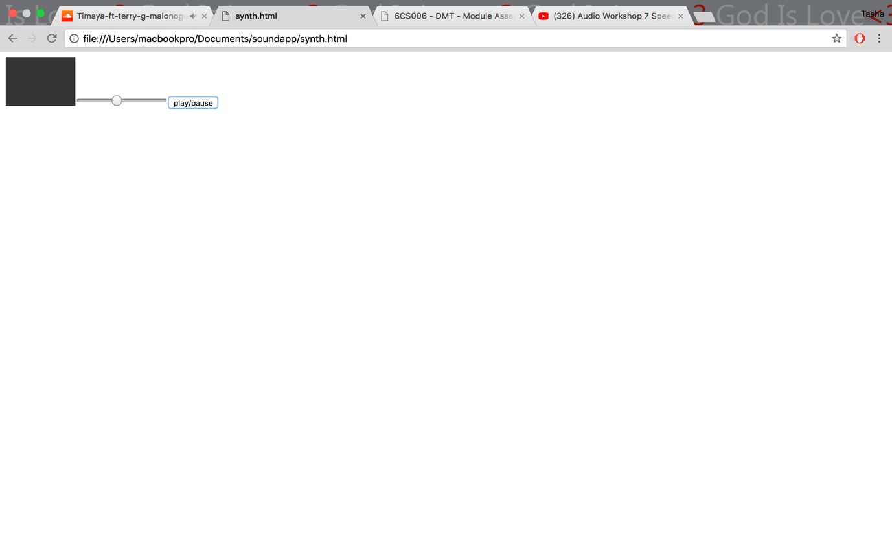

*Fig 8- oscillator sound waves*

The Soundapp application is capable of synthesising oscillator sound waves.

* Sine wave
* Sawtooth wave
* Square wave
* Triangle wave

Fig 8 shows a basic interface that has a play and pause button. When a button is clicked, the selected oscillator wave plays and the frequency can be adjusted using the slider.

**Draw visualisation**

The application’s main challenge was to enable users to load and play two files simultaneously. This requirement was made possible by creating two canvases in the same HTML file giving them different canvas IDs. For player1, the canvas ID is ‘*canvasa’* and for player2 the ID is ‘*canvasb*’. Differentiating the two canvases enabled the waveforms to be displayed simultaneously on the same page. The image below (fig 9) shows the two canvases used to visualise the waveform of the selected sound.

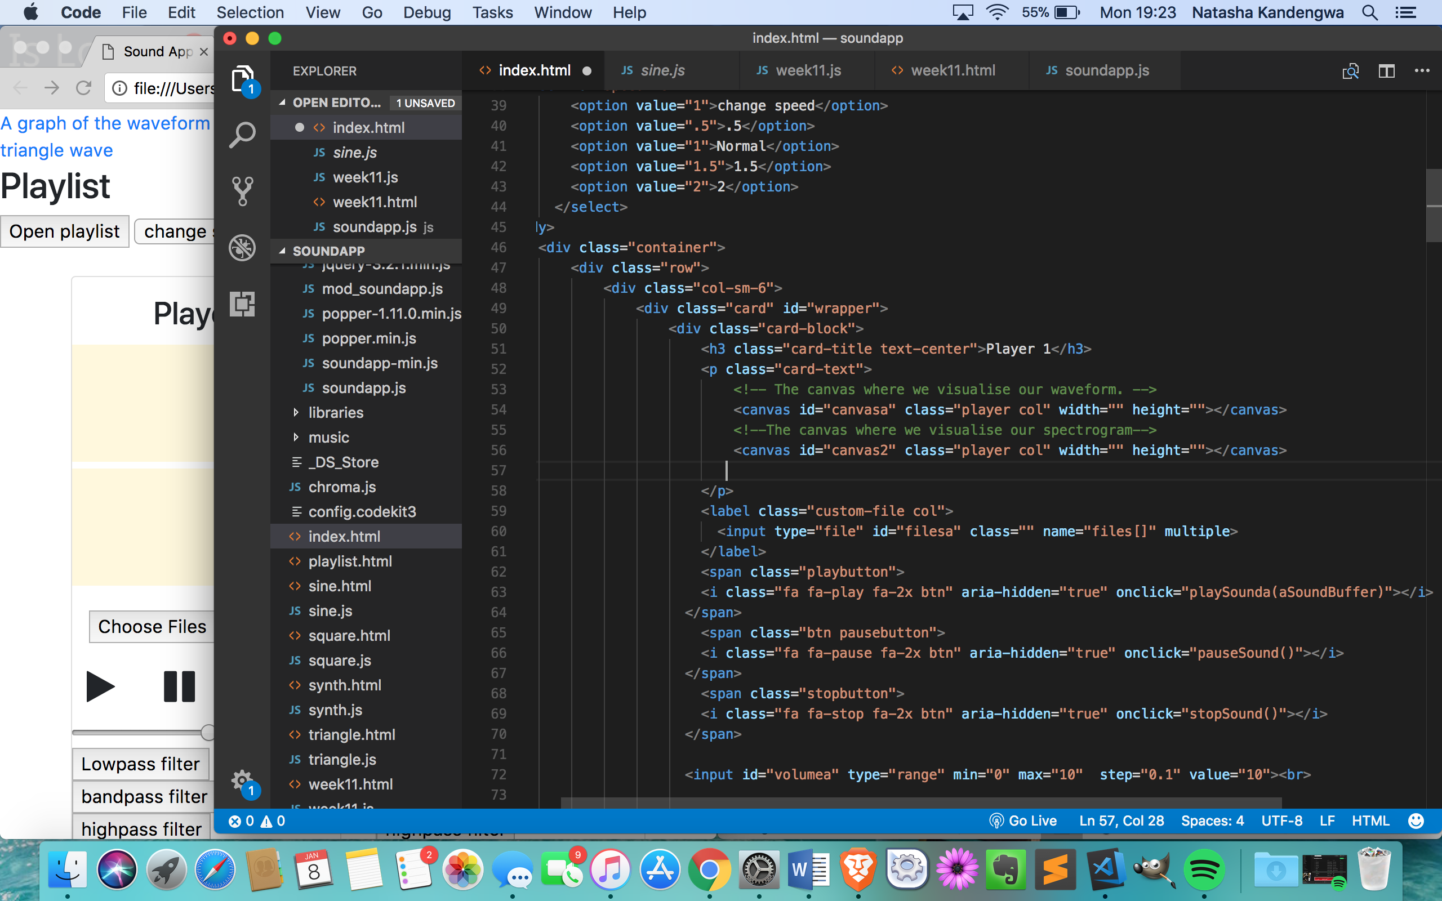

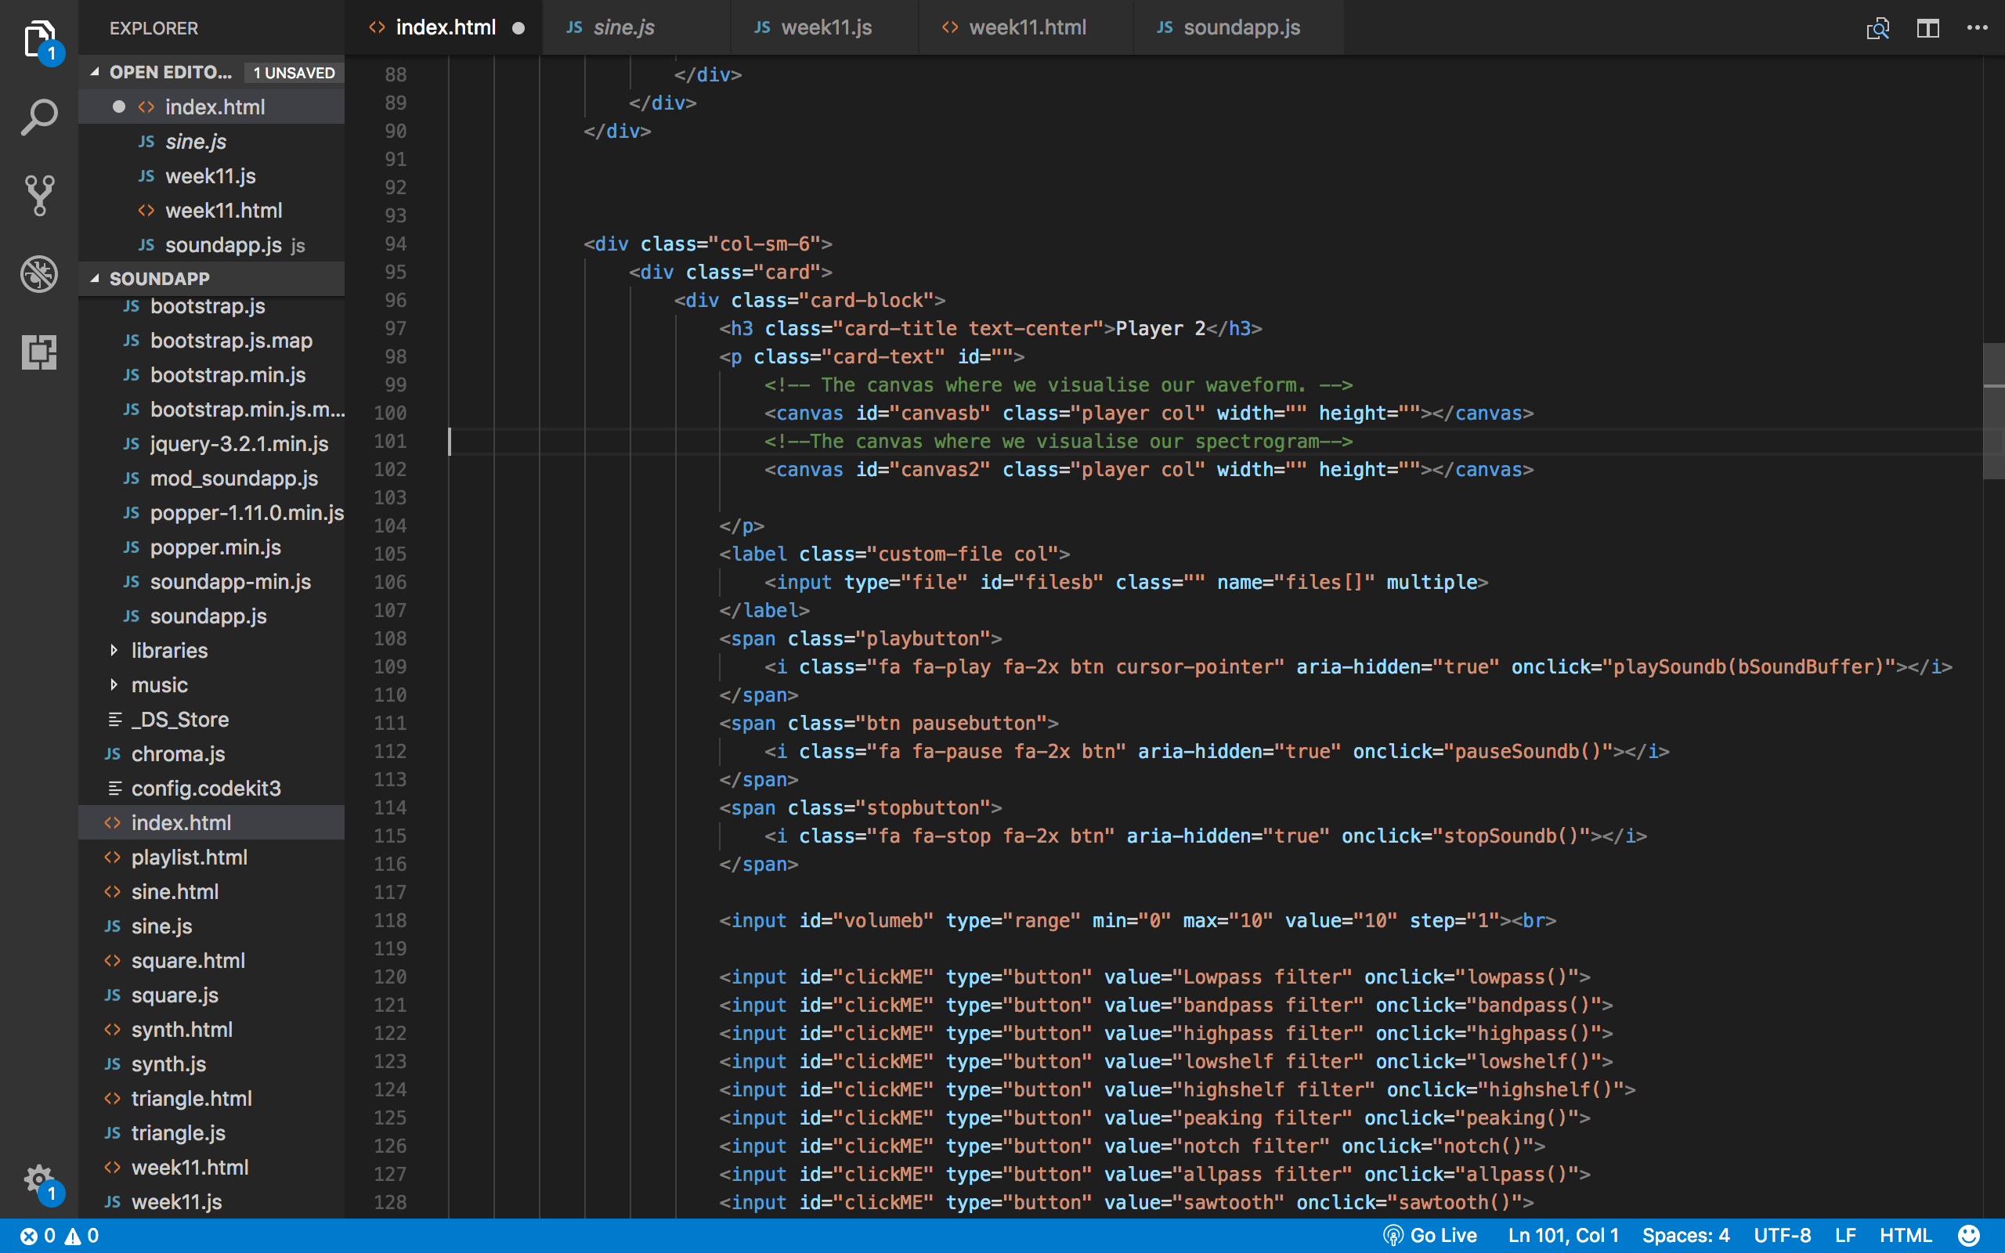

*fig 9- canvasa and canvasb*

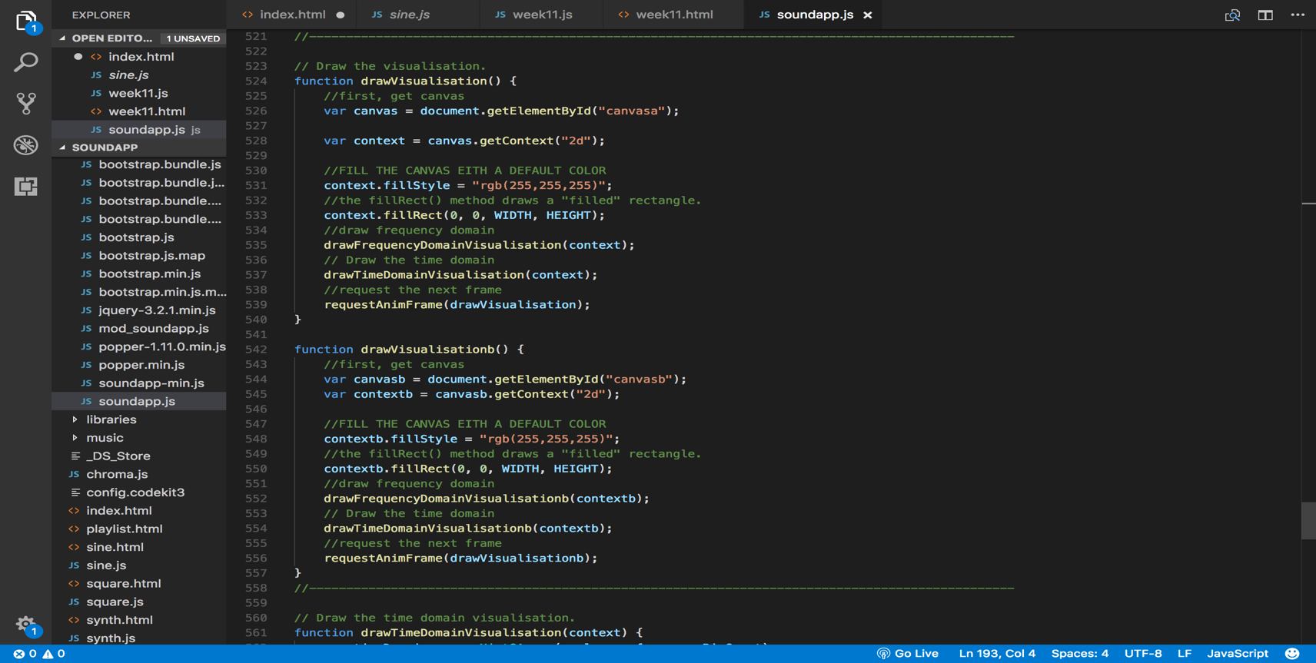

*fig 10- draw visualisation function*

Above is an image that shows the JavaScript used to draw the visualisations of the selected sound. The function first of all gets the canvas by the ID name, and then displays the canvas with any chosen colour, in this case, white will be displayed because the set context fill style is 255, 255,255. The main aspect of the code above is the function names. Because we want the canvases to be drawn and displayed on the same page, the function names should not be the same. Fig 10 shows the player 1 having the function ‘*draw visualisation’* while player 2 has the function of ‘*draw visualisationb’.*

**Event listener**

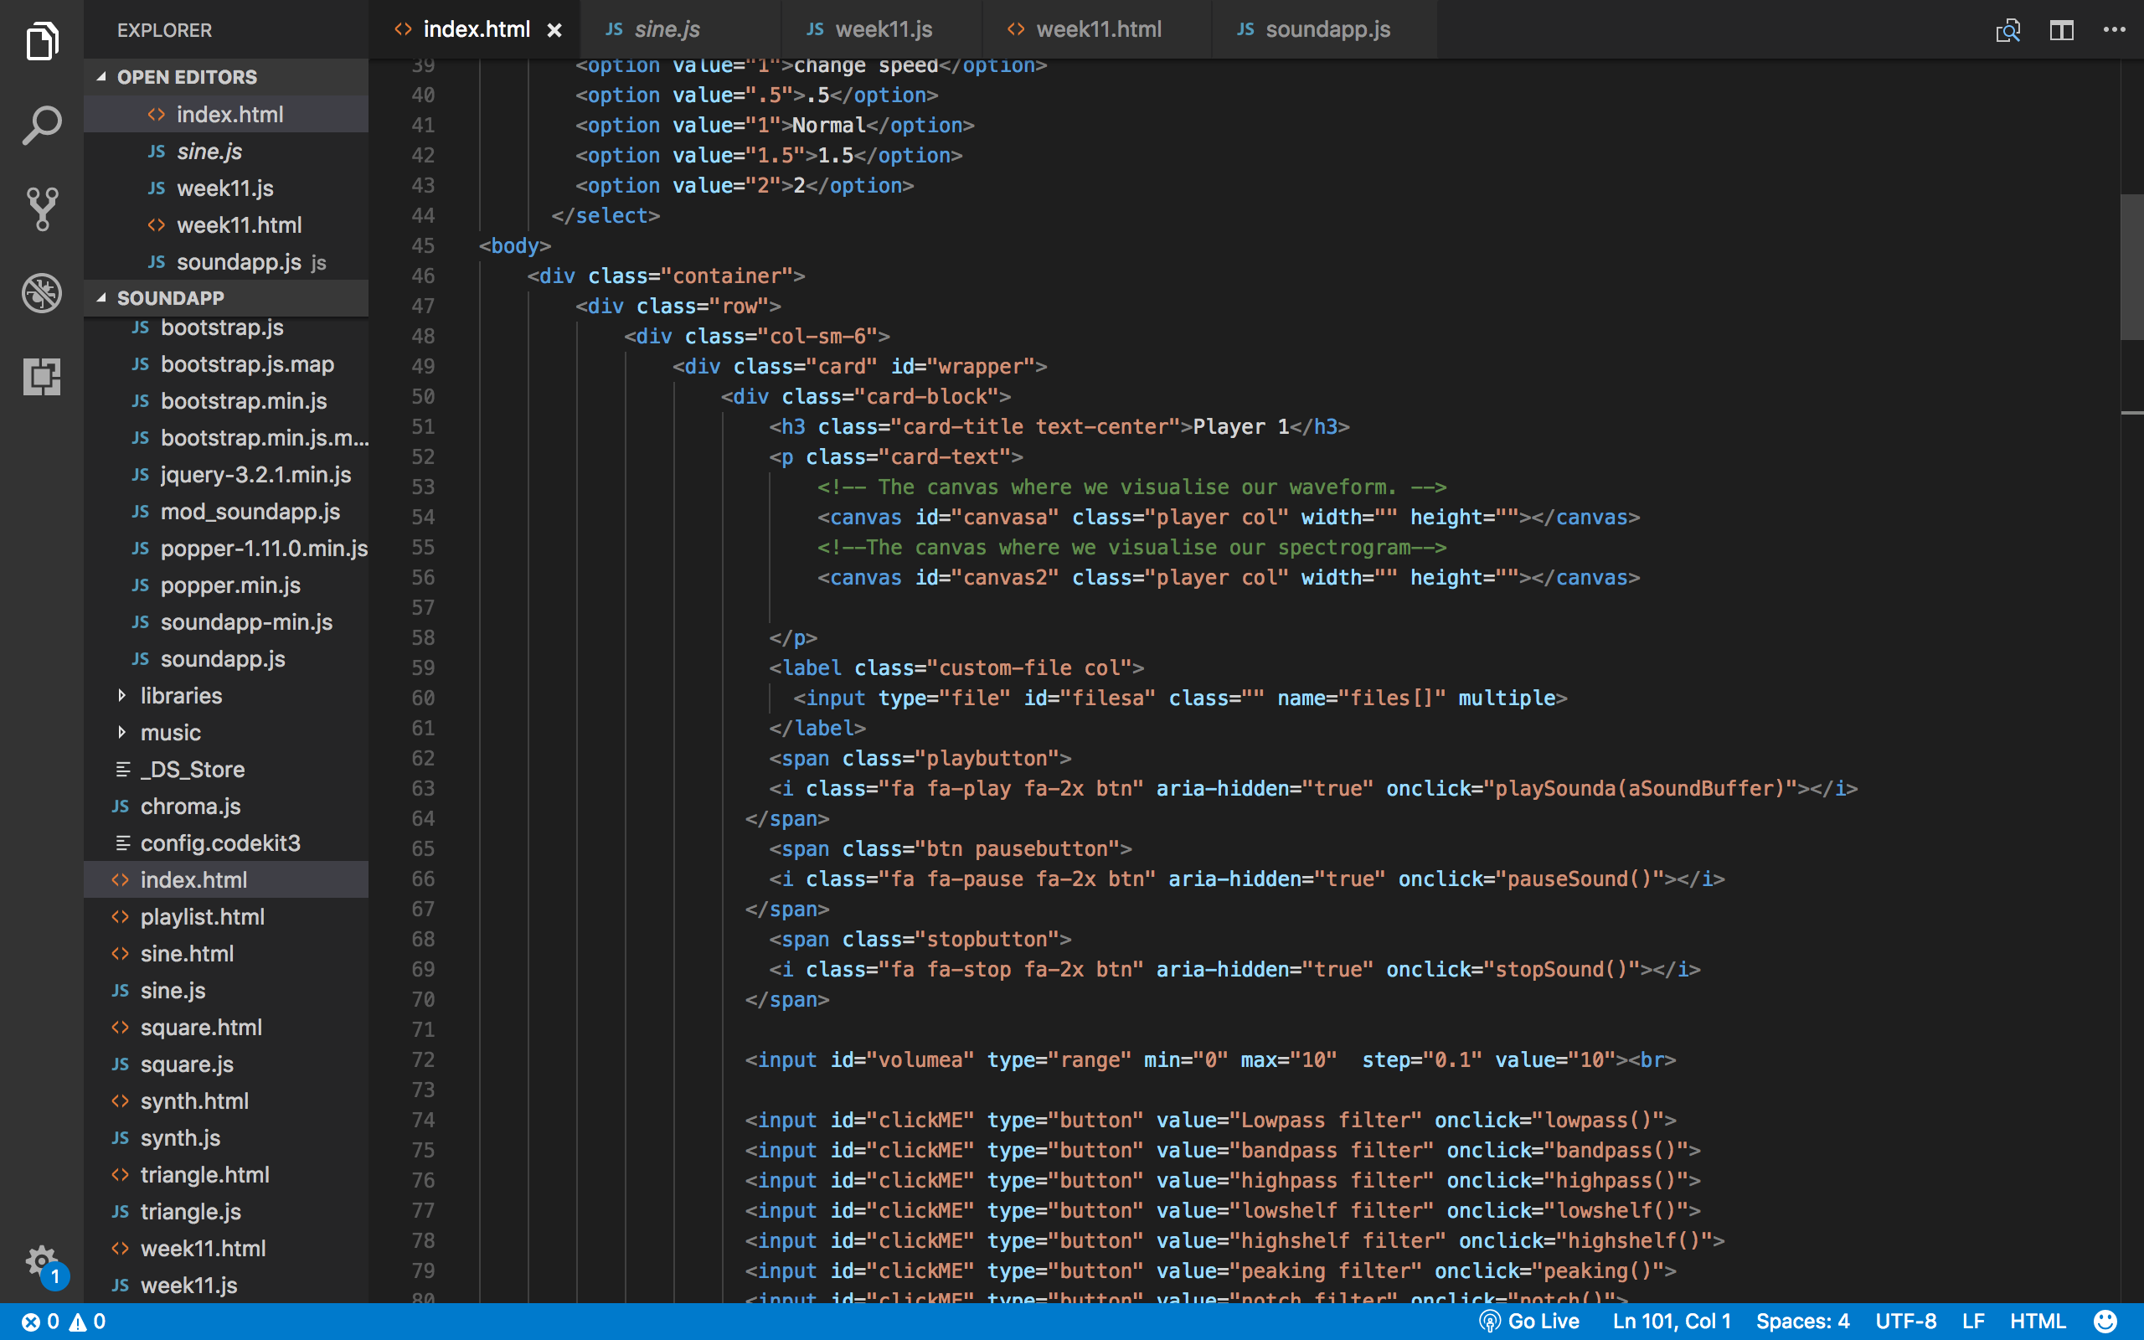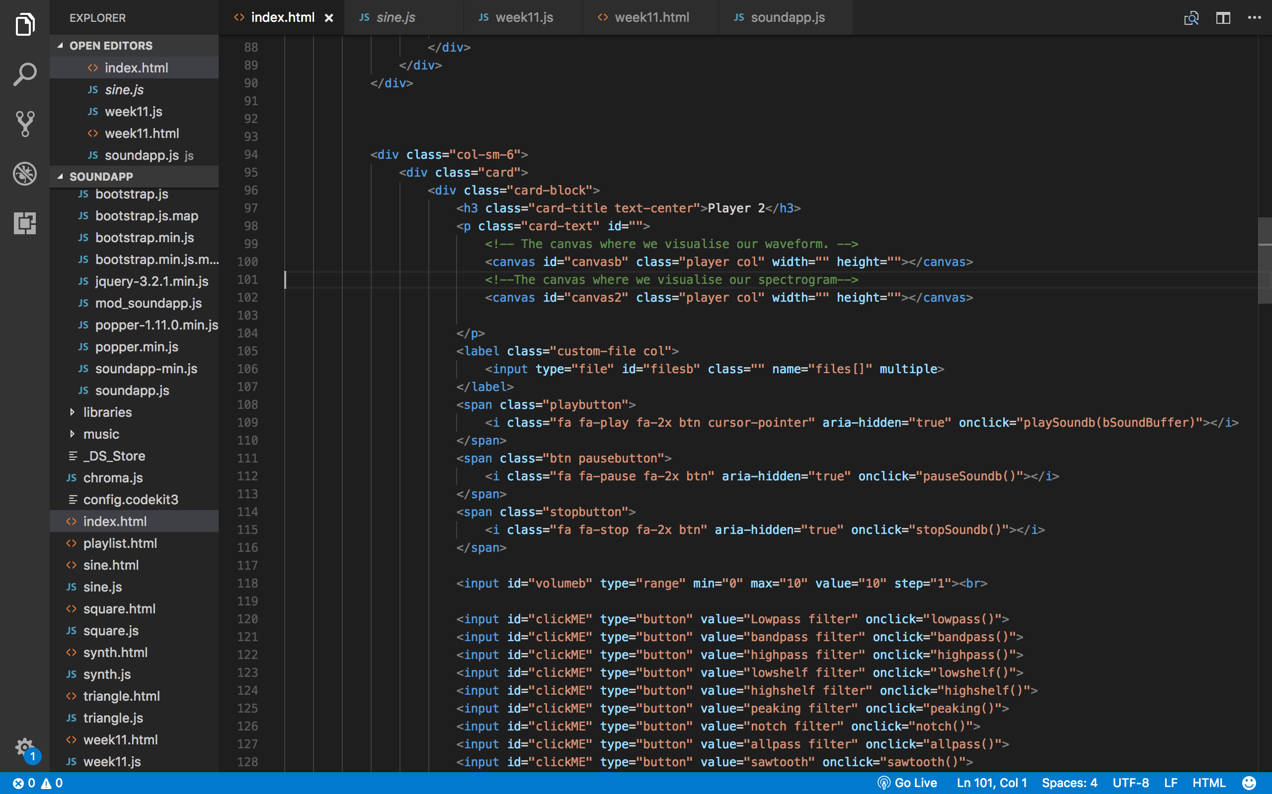

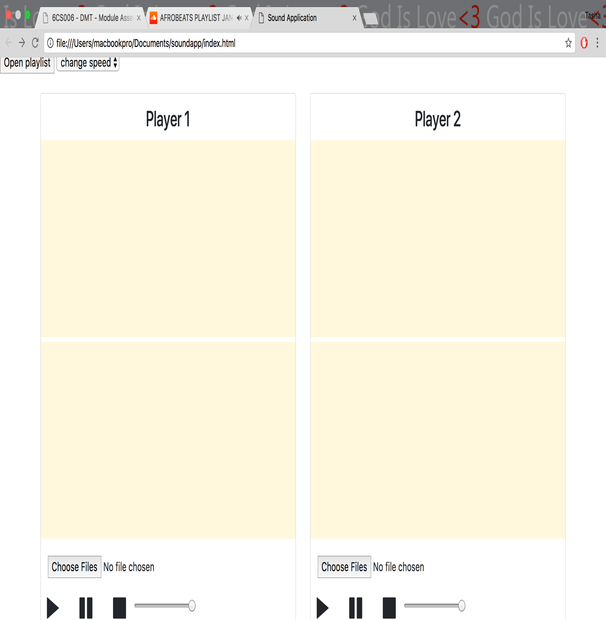

*fig 11- File inputs*

The file input with the Id of ‘filesa’ creates an input option for a user to access and select files from the computer and load them on the canvas for player 1. The file input with the id of ‘filesb’ creates an input option for a user to access and select files from the computer and load them on the canvas for player 2.

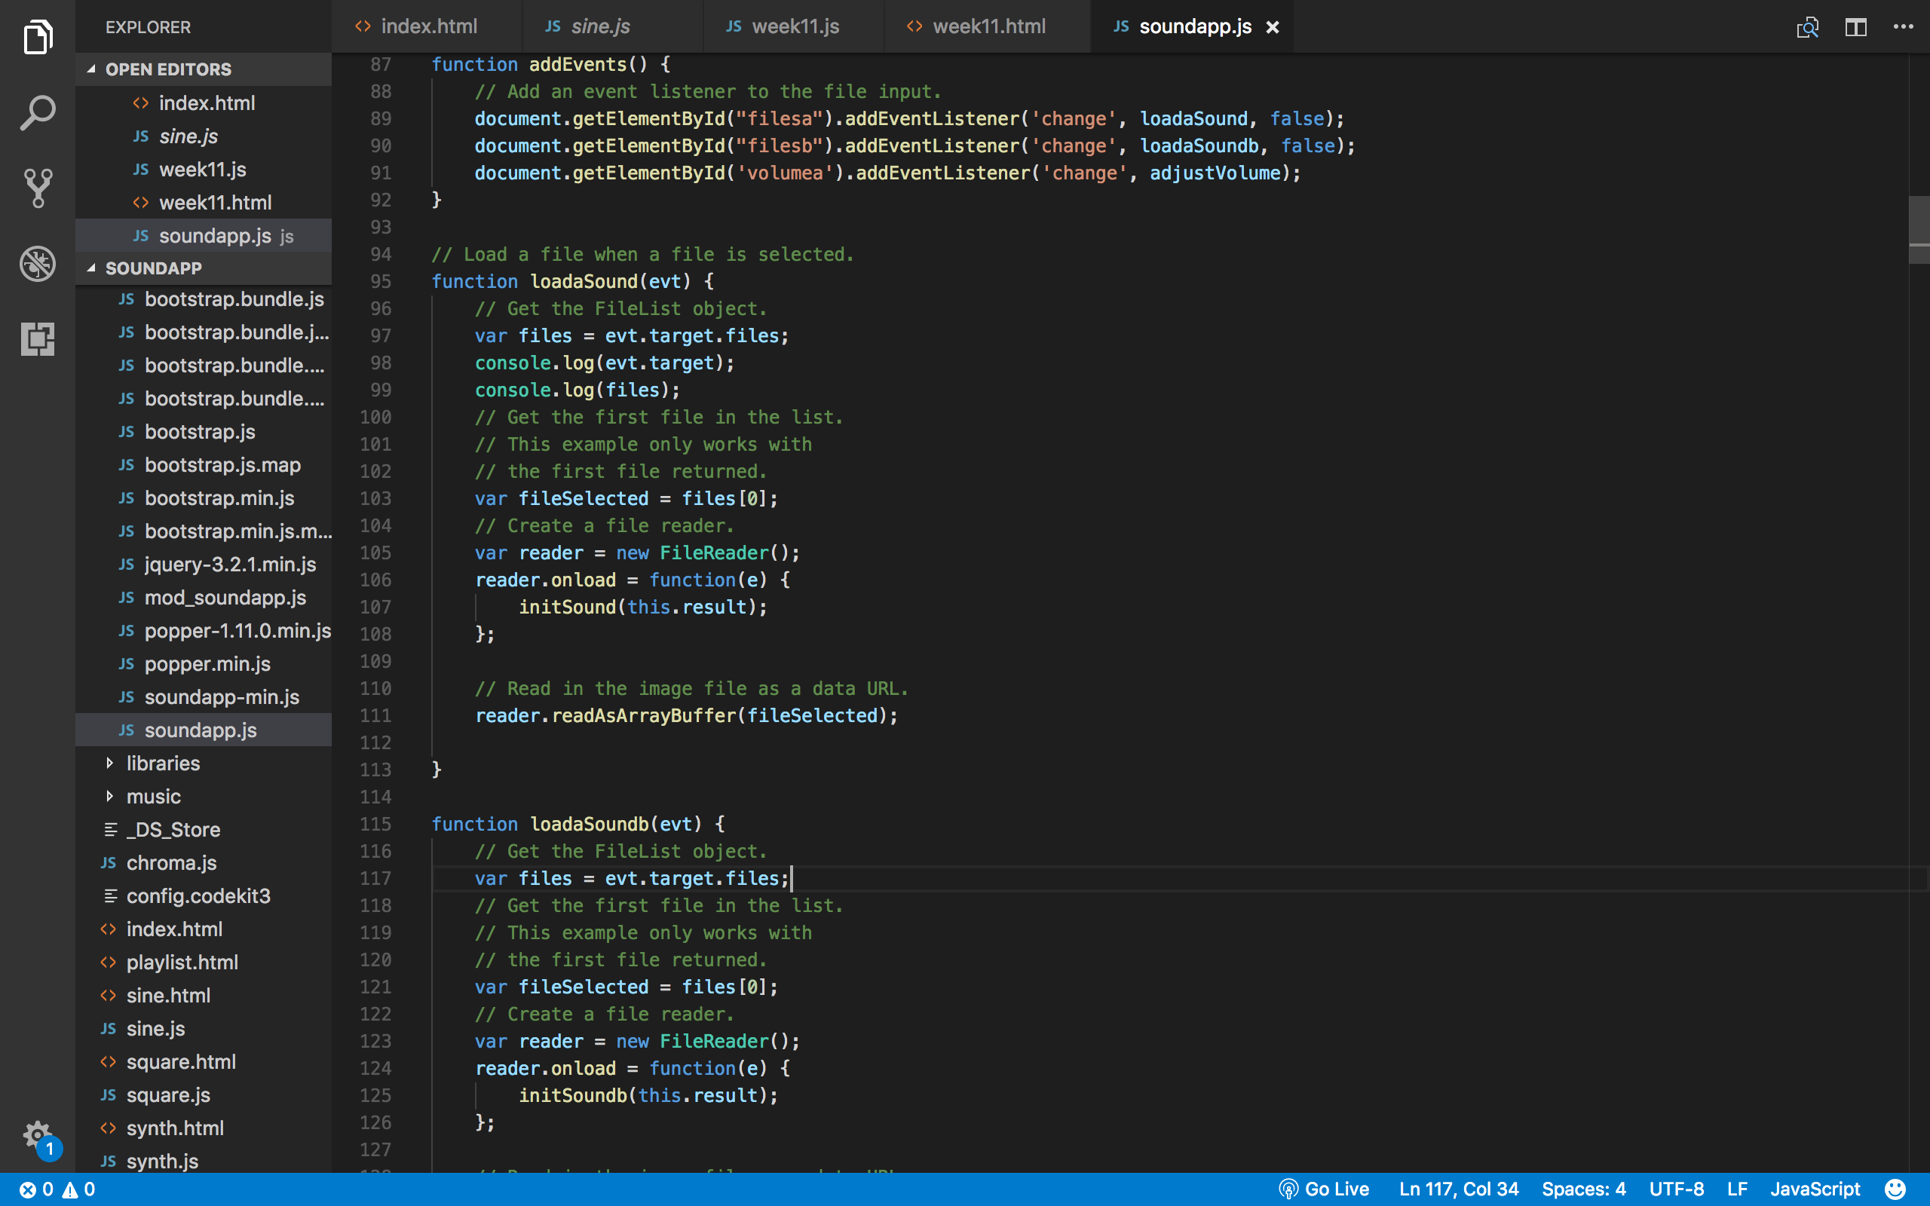

*fig 12- load events*

The function addEvents adds an event listener to the file inputs. The code accesses the id of the file input and adds an event listener to execute the loadsound and loadsounb functions. Fig 12 shows how the application executes the loadsound and loadsoundb events when the user selects a file from the computer. Having the same functions with two different function names allows the application to individually recognise a selected file and loads it separately.

**Sound Filters**

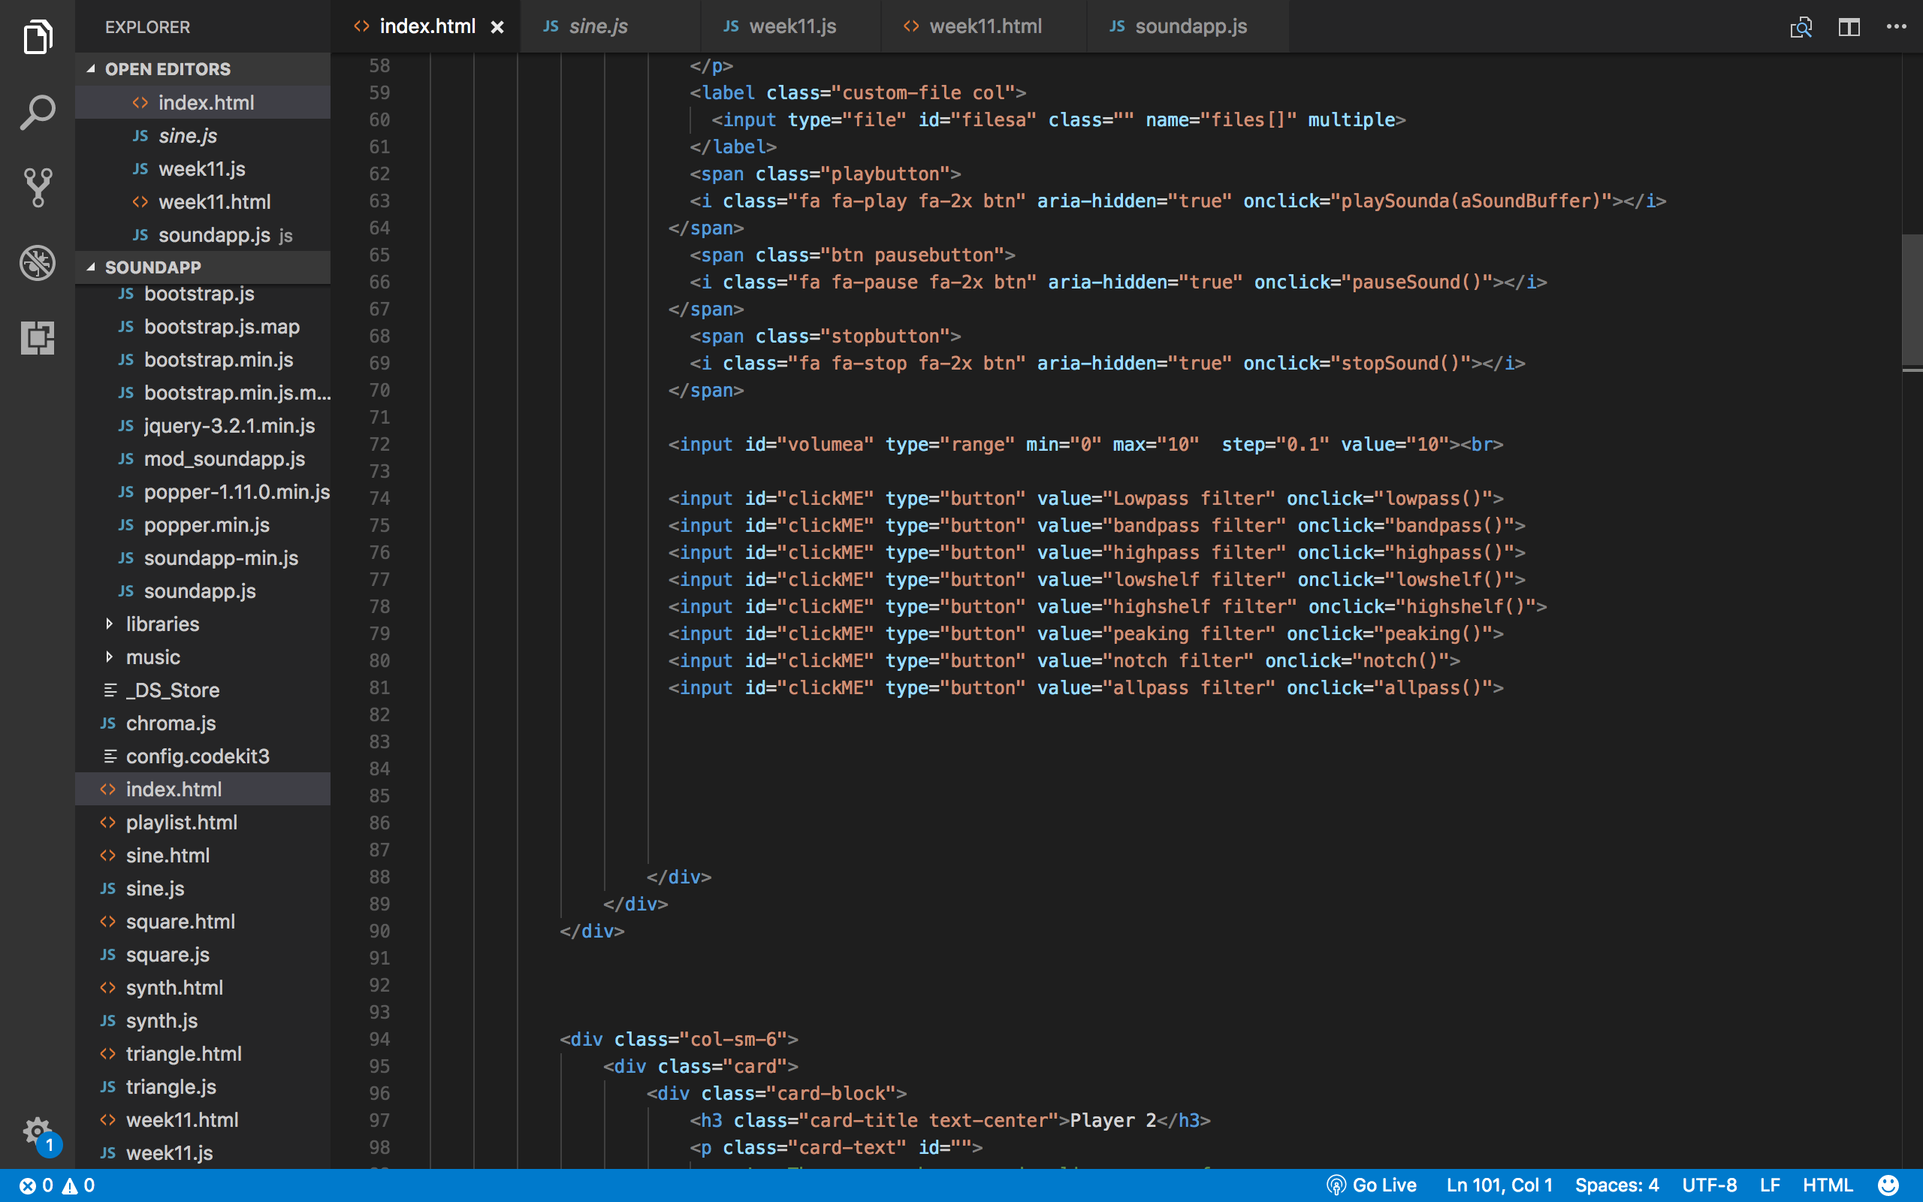



*fig 12- filters*

The application includes eight sound filters. These are:

* Low-pass filter
* Band-pass filter
* High-pass filter
* Low-shelf filter
* High-shelf filter
* Peaking filter
* Notch filter
* 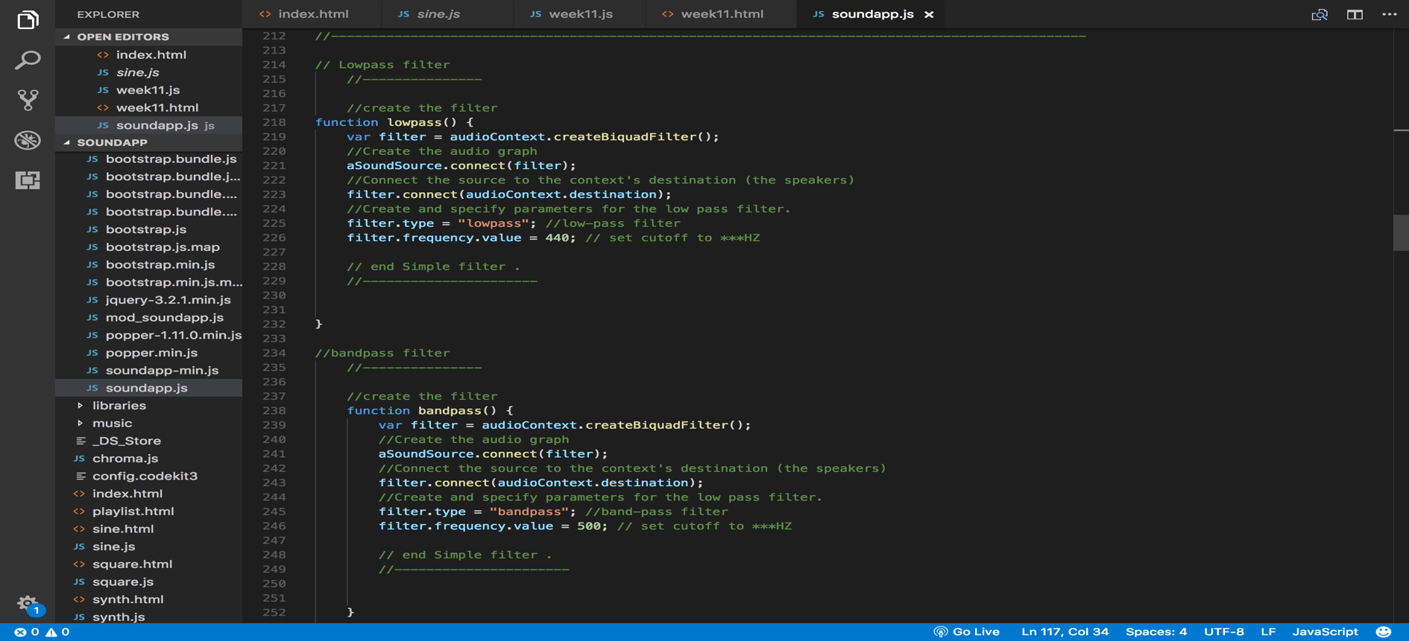All-pass filter

Fig 12 shows the filter options available. The filters options are displayed as buttons, and when clicked, the onclick function is executed and the filter will be applied to the sound.

Each filter has its own unique function that creates and specifies parameters for that particular filter. The filter type will play based on the set filter frequency value, for example, fig 13 shows the functions for low-pass and band-pass filters with low-pass set at a frequency of 440 hz and band-[ass set at a frequency of 500 hz.

*Fig 13- filter functions*

**TestSoundE.wav**

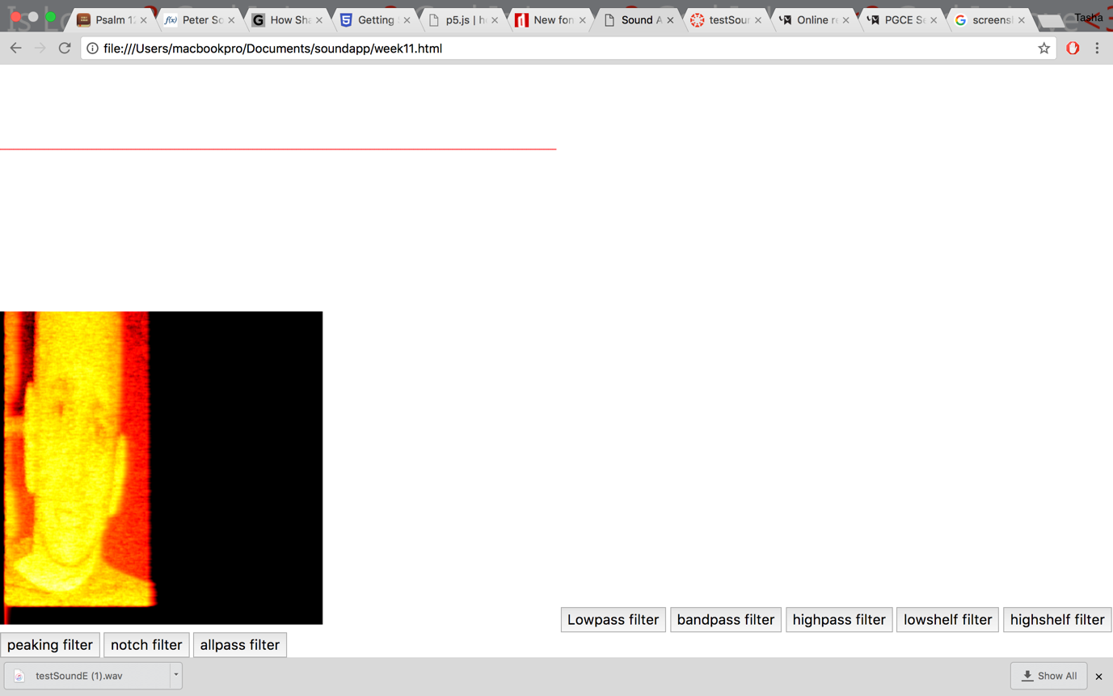

The testSoundE.wav is an image converted into sound and is displayed on the spectrogram when the user plays the sound. Since spectrograms are pictures of sound over time, they are used to visualise musical waveforms and sounds in speech. The waveform above shows a hidden image in the sound.

**Key principles of search algorithms**

* Noise and distortion resistant
* Voice codec compression
* Searching and scoring
* Fast combinatorial hashing

A spectrogram includes a comprehensive image that represent the audio and is usually presented in either 2D or 3D format. The spectrogram presents a graph that displays the audio depending on time and frequency as well as the amplitude of the frequency components.

***How computers view audios***

Computers view audio files in either waveforms or spectrograms. A waveform is presented as a graph that represents a recoding or an audio signal. The graph indicated changes in the amplitude over certain amount of time. The waveform represents the amplitude of the sound by measuring the Y-axis and also represents the time by measuring the x-axis. Waveforms provides a clear visual idea what the audio is how it has been recorded. For example, a low waveform indicates soft and low audio while a high waveform indicate that the audio was set and recorded on high levels. The inconsistency of the waveform also enables an individual to dictate parts of the audio due to the changes in the waveform.

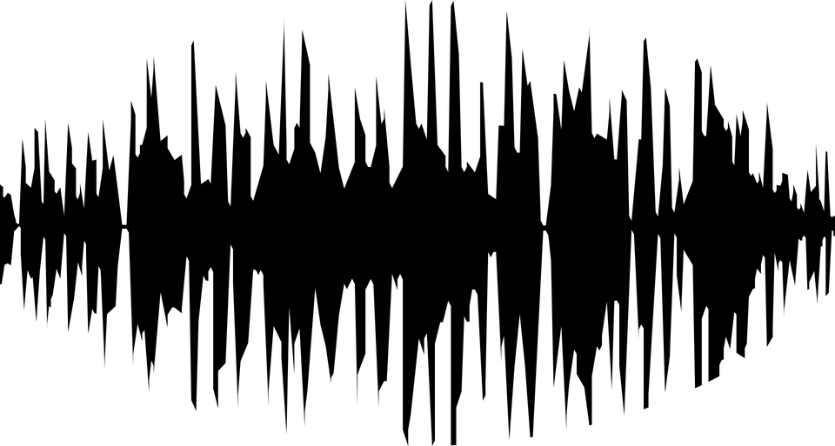

* *Fig 1- Waveform(*Pixabay.com. (2018). *Free Image on Pixabay - Audio, Music, Sfa Jazz, Sound, Wave*. [online] Available at: https://pixabay.com/en/audio-music-sfa-jazz-sound-wave-1293262/ [Accessed 7 Jan. 2018].)

For example, the low parts of the waveform indicate low to medium sounds, probably vocals and low instrumental sounds. The high parts of the waveform indicate the high notes or the drums, base and guitar.

**Spectrogram analysis- audio search algorithms**

**Shazam**

Search engines utilizes algorithms that are capable of returning and displaying results based on what the user inputs into the search bar. These results can be text, images or videos. Shazam is an audio search engine used to identify audios by submitting a snippet of a recording. This identification service utilizes algorithms that rapidly gives back results to the user and also giving accurate information about the audio as well as artist information.

*Shazam basic audio search process*

* Shazam individualizes an extensive range of music and stores the songs with unique identifications fingerprinting each song.
* A user records a ten second clip of a desired song and Shazam will give the recorded song a unique fingerprint.
* Shazam will then upload the clip’s id in order to run a search in the database for a matching fingerprint where millions of songs are stored
* The results with the song information is displayed to the user if a match is found

*Shazam fingerprinting*

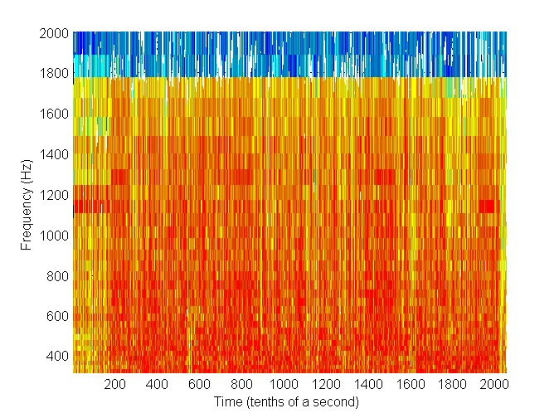

*Fig2- Song Spectrogram (*Full song spectrogram Accessed Dec 28, 2-17 https://echosoftware.wordpress.com/how-it-works/spectrogram/full-song-spectrogram/)

An audio file contains a time frequency graph known as a spectrogram. It contains time as one of the axis, another one as frequency and the third as intensity. The graph demonstrates the intensity of a frequency at a particular time.

Shazam uses an algorithm that construct the spectrogram *(fig2)* and then fingerprints the song in order to indicate the peak intensity of the spectrogram. From the moment Shazam begin to record an audio, it keeps track of the time and frequency of the peak intensities of that particular song. The fingerprint lists is constructed by Shazam as a hash table with frequency in HZ and time is seconds. After retrieving a fingerprint, Shazam uses the frequency to search the database for matching songs.

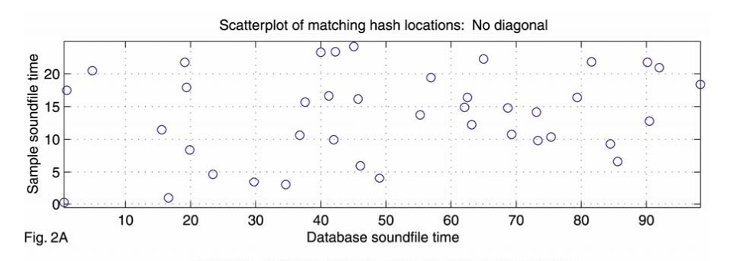

The graph above (fig.2A) demonstrates the frequency matches between the songs and the recorded snippets. These frequencies are not accurately aligning in time and as a result, there are no matched found. *Li-Chun. An Industrial-Strength Audio Search Algorithm. Shazam Entertainment, 2003. Fig. 2A.*

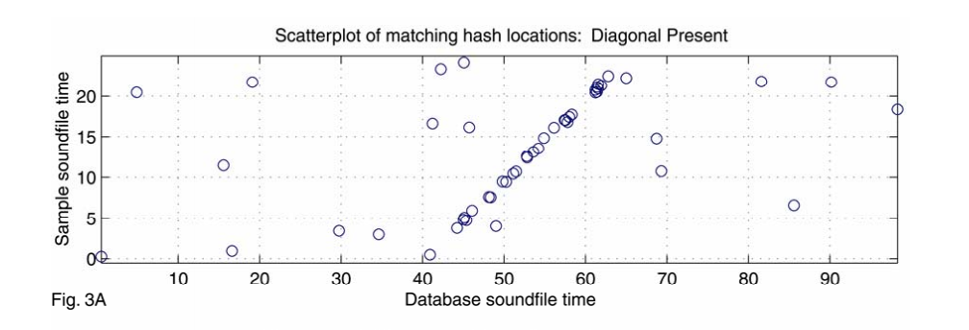

The graph above(fig.3A) indicates how the frequency matches are properly occurring concurrently and as a result, the recorded snippet matches the song***.*** *Li-Chun. An Industrial-Strength Audio Search Algorithm. Shazam Entertainment, 2003. Fig. 3A*

*Noise and distortion resistant*

One of the most astounding features of Shazam is the accuracy of the service. Shazam is capable of recognising and identifying indeterminate songs regardless of the background noise. This is made possible by the noise and distortion resistant process that Shazam acquires making it possible for users to search for songs buy recording snippets even in crowded and noisy environments.

**An analysis of the finished product**

The Soundapp application meets most of the requirements indicated in the requirements specifications. Below is a list of the features and functionalities implemented on the application.

* The user can control playback for each and both sounds
* Play, pause and stop buttons are fully functional. Issues with the volume slider occurred during the development process. The slider does not function as intended.
* The application includes a speed control option for playing sounds.
* The application has a total of eight filter options that can be applied to a playing song
* The application can synthesize oscillator-based sound waves – sine, Sawtooth, square and triangle
* The user can also manipulate the oscillator waves by using a slider to change the frequency
* The application supports the time, frequency and waveforms for both sounds. An issue occurred when attempting to display the spectrogram for both sounds. The issue was fixed by creating a separate draw spectrogram visualisation function to display on a separate canvas.

**References**

* Christensson, Per. "Waveform Definition." TechTerms. (2006). Accessed Dec 28, 2017. <https://techterms.com/definition/waveform>.
* Full song spectrogram Accessed Dec 28, 2-17 <https://echosoftware.wordpress.com/how-it-works/spectrogram/full-song-spectrogram/>
* How Shazam works Accessed Dec 28, 2-17 Gizmodo.com https://gizmodo.com/5647458/how-shazam-works-to-identify-nearly-every-song-you-throw-at-it
* P5js.org. (2018). *p5.js | home*. [online] Available at: https://p5js.org/ [Accessed 7 Jan. 2018].
* Pixabay.com. (2018). *Free Image on Pixabay - Audio, Music, Sfa Jazz, Sound, Wave*. [online] Available at: https://pixabay.com/en/audio-music-sfa-jazz-sound-wave-1293262/ [Accessed 7 Jan. 2018].
* Full song spectrogram Accessed Dec 28, 2-17 <https://echosoftware.wordpress.com/how-it-works/spectrogram/full-song-spectrogram/>
* Perso.ens-lyon.fr. (2018). *Cite a Website - Cite This For Me*. [online] Available at: http://perso.ens-lyon.fr/patrick.flandrin/CIRMMT12c.pdf [Accessed 3 Jan. 2018].
* Uk.mathworks.com. (2018). *Practical Introduction to Time-Frequency Analysis - MATLAB & Simulink Example - MathWorks United Kingdom*. [online] Available at: https://uk.mathworks.com/help/signal/examples/practical-introduction-to-time-frequency-analysis.html?requestedDomain=www.mathworks.com [Accessed 3 Jan. 2018].
* Toptal Engineering Blog. (2018). *How does Shazam work? Music Recognition Algorithms, Fingerprinting, and Processing*. [online] Available at: https://www.toptal.com/algorithms/shazam-it-music-processing-fingerprinting-and-recognition [Accessed 3 Jan. 2018].